

**Name:** Hanzala Javaid

**Reg No:** 4288-FBAS/BSCS4/F20

**Subject:** Introduction to Data Base

**Submitted To:** Professor Imran Saeed

**Topic**

“**Car Rental System”**



**Preface**

1.0 Introduction

2.0 Existing System (No system or Manual System)

2.1 Issues/Drawbacks in Existing system

3.0 Proposed System

3.1 Advantages in Proposed System

4.0 Data Requirement

4.1 Entity Classes

4.2 Attributes of each Entity Class

4.3 Tables

4.4 Bubble Chart

4.5 Data Structure Diagram (DSD)

4.6 Entity Relationship Diagram (ERD)

5.0 Logical Data Model

5.1 Representation of Entity Classes

5.2 Represent Relationship

**Appendix-A**

6.0 Forms

7.0 Reports

**1.0 Introduction**

As we all know that data has now become a vast feature of every field of life without data, nothing can exist. But when we talk about its storage, then it became a source of concern. We can loss many data if we will not store it, where it is safe, reliable and efficient.

My Data Base is related to “Car Rental System”, which has now become a dire need for car rental systems. This Data Base will surely help them in their work and will become a source of convenience for them as well as customers. So, we have basically automated this car rental system. So, by keeping this system, many problems can be overcome.

**2.0 Existing System (No system or Manual System)**

In existing system of car rental stores/organizations, there are many issues like they have to kept the records of customers, cars, employees, monthly reports etc manually. So, due to this there is a possibility of losing of data because it is kept manual. Moreover, the organization owner and employees can also face lot of problems like if he/she wants to access or update his yearly reports or cars information, it will waste their time and human error can also come in the way. So due to this, many problems can be faced.

**2.1 Issues/Drawbacks in Existing system**

There are many drawbacks in existing system because as we know that data is kept manually. So due to manual data keeping system, although the storage of data happens but factors like efficiency and reliability can’t be achieved. Due to this, chances of human errors may take place and calculations like monthly reports can take too much time.

**3.0 Proposed System**

In proposed System, data is not store manually. It is stored in data base. I have made the data base which can easily store the information of organization and its center in different cities, Employee records, Customer and booking records, car records and information, and Yearly revenue and profit reports of the car rental Organization and many more. We have basically automated this car rental system. So, by keeping this system, many problems can be overcome.

But if we want to keep the data in Data Base, we need an explicit backup. As, Data Base contains the data of whole organization the copy or backup of Data is mandatory. So that in case of loss of data from real Data Base, we can recover Data with the help of explicit backup.

**3.1 Advantages in Proposed System**

As the proposed system tells us that data is store in database which now has become collection of logically related data that can be shared by multiple users. So, by keeping data automated, it will surely store the data with efficiency and reliability. Calculation doesn’t take so much time and chances of human error has removed. The sharing of data will also take place. Moreover, the data of respective organization will keep safe and security measures also take place. So, proposed system is beneficial for all users.

**4.0 Data Requirement**

Data requirements definition establishes the process used to identify, prioritize, precisely formulate, and validate the data needed to achieve business objectives.

In this project, I have stored the data in the form of tables, reports and form.

**4.1 Entity Classes**

I have included five entity classes named as follows:

* Organization (Information of Car Rental Store/Organization)
* Car (Information about Cars)
* Customer (Information of Customer)
* Employee (Information of Employee)
* Yearly Report (Yearly Report of the Organization)

**4.2 Attributes of each Entity Class**

* Organization (Organization Name, Center, Center_ID, Ph_Num, Email)
* Car (Car_Name, Engine_Num, Chasis_Num, Car_Model, Car_Clr)
* Customer (Name, ID, Email, Residence, Car_Booked)
* Employee (Emp_Name, Emp_ID, Emp_Designaion, Emp_Salary, Ph-Num)
* Yearly Report (Year, Total_Rides, Total_Revenue, Profit, Tax_paid)

**4.3 Tables**

**Tble: Organization**

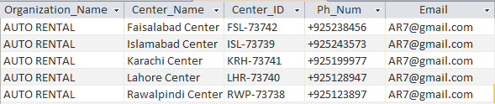

**Tble: Car**

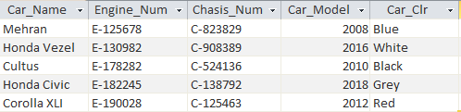

**Tble: Customer**

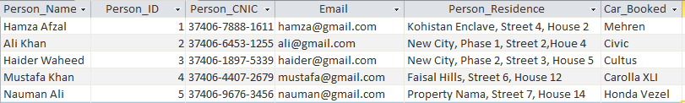

**Tble: Employee**

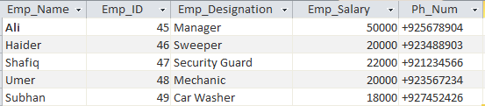

**Tble: Yearly Report**

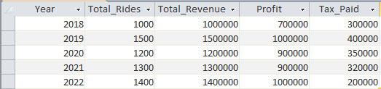

**4.4 Bubble Chart**

**Entity class 1: Organization**

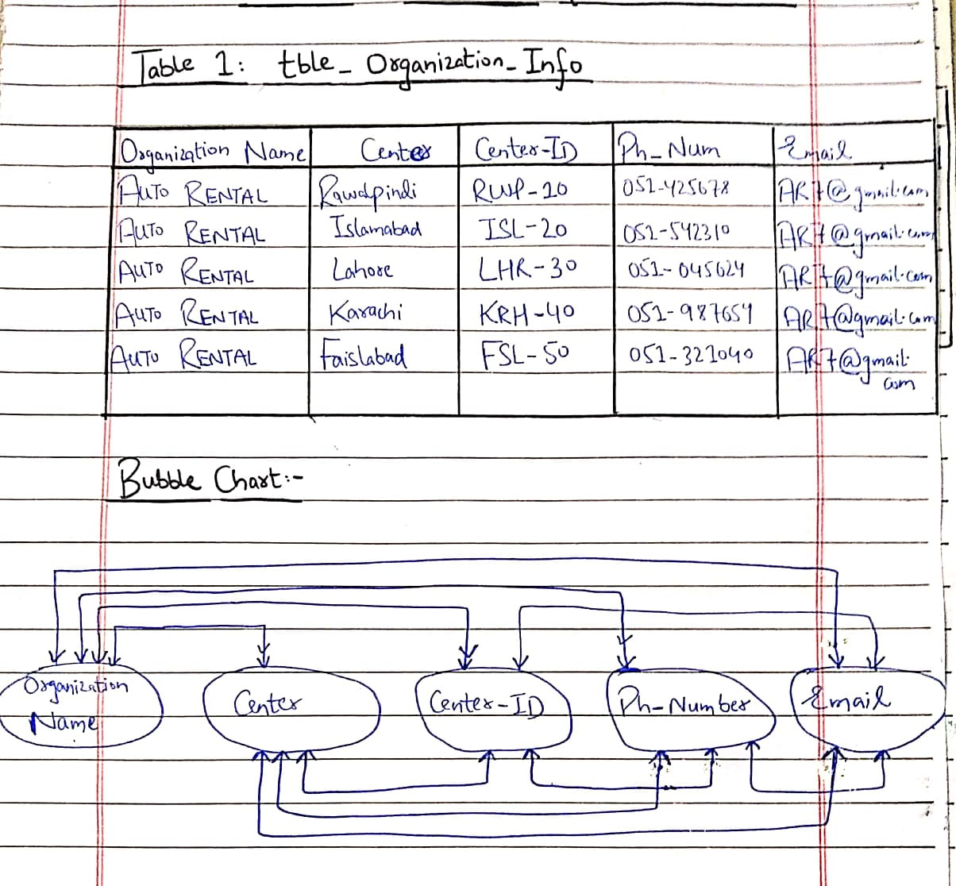

**Candidate Key Attribute:** Center_Id, Ph_Num, Email

**Primary Key Attribute:** Center_ID

**Alternate Key Attribute:** Ph_Num, Email

**Secondary Key Attribute:** NiLL

**Non-Key Attribute:** Organization Name, Center Name

**Entity class 2: Car**

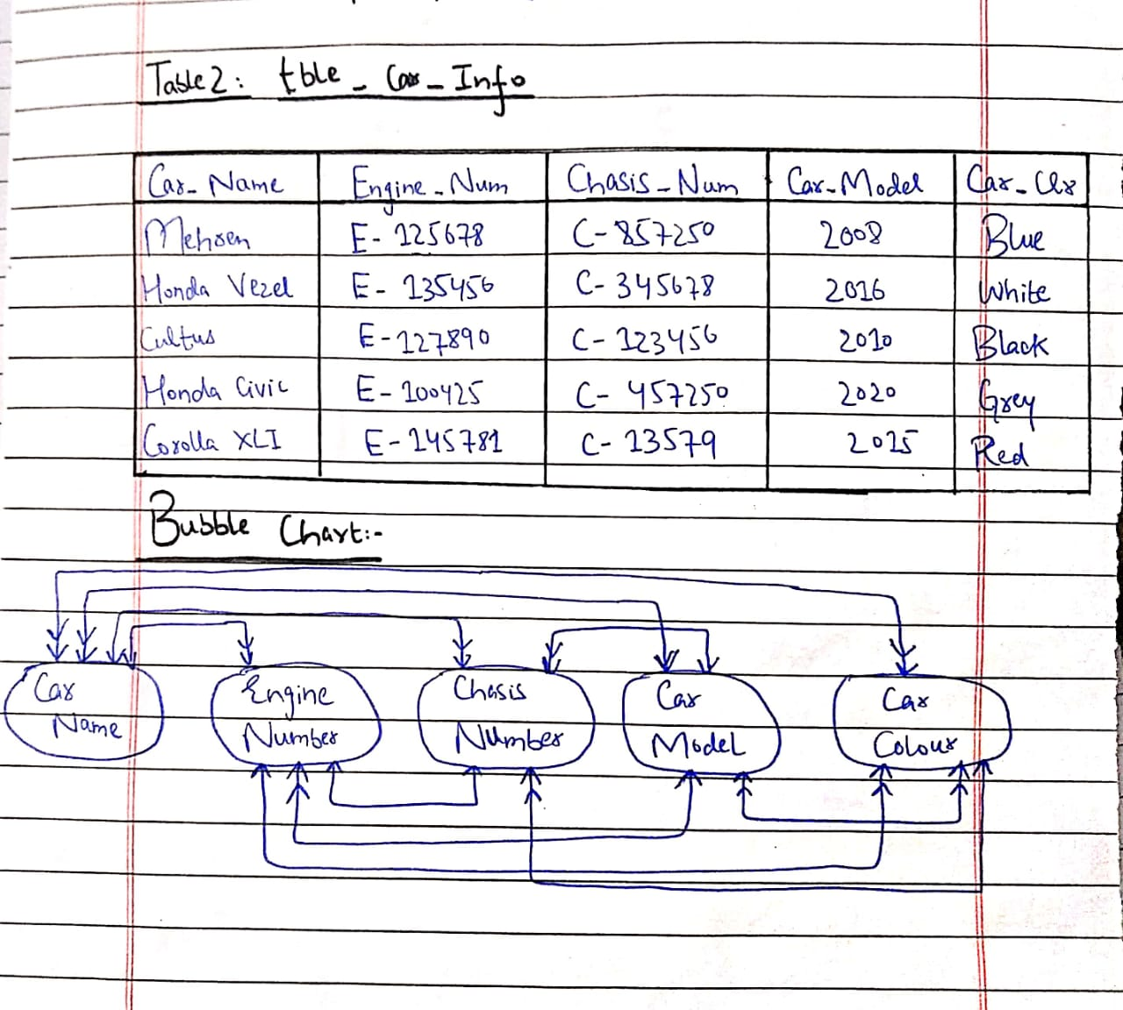

**Candidate Key Attribute:** Engine_Num, Chasis_Num

**Primary Key Attribute:**  Chasis_Num

**Alternate Key Attribute:**  Engine _Num

**Secondary Key Attribute:** Car Color, Car Model

**Non-Key Attribute:** Car Name

**Entity class 3: Customer**

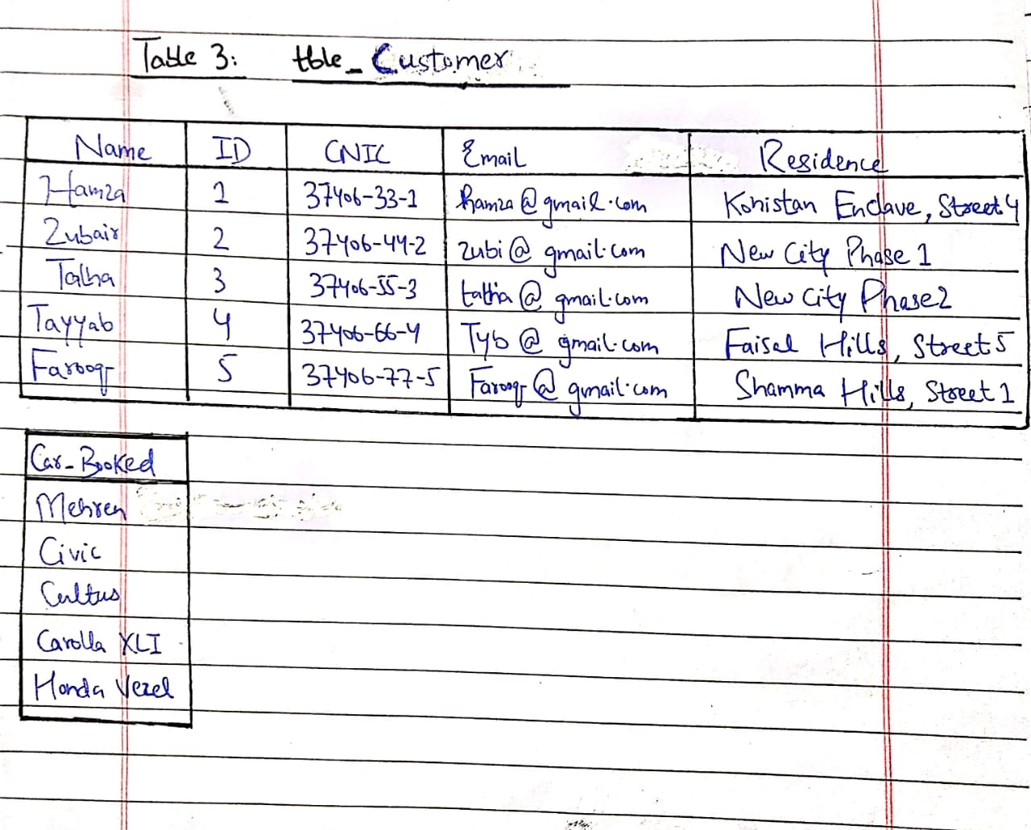

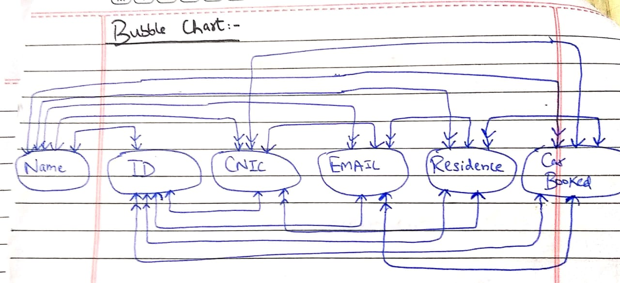

**Candidate Key Attribute:**  ID

**Primary Key Attribute:** ID, Email, CNIC

**Alternate Key Attribute:** CNIC, Email

**Secondary Key Attribute:** Residence

**Non-Key Attribute:** Name, Car Booked

**Entity class 4: Employee**

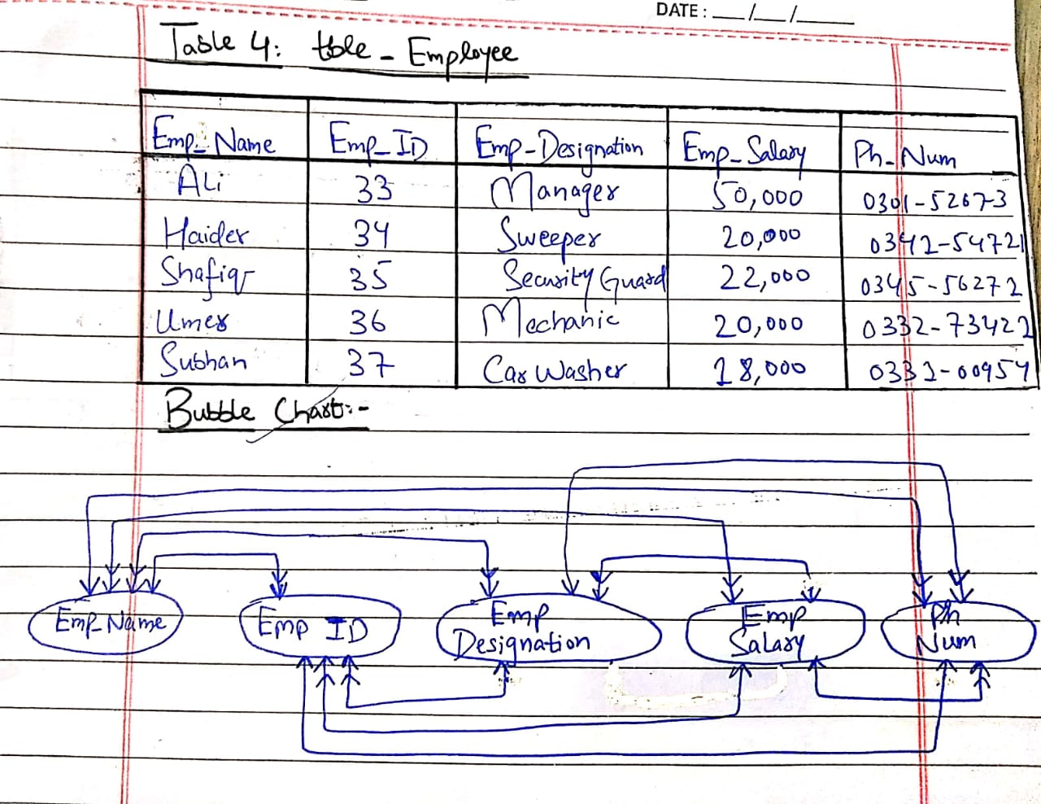

**Candidate Key Attribute:** Emp_ID, Ph_Num

**Primary Key Attribute:** Emp_ID

**Alternate Key Attribute:** Ph_Num

**Secondary Key Attribute:** Emp Salary

**Non-Key Attribute:** Emp Name, Emp Designation

**Entity class 5: Yearly Report**

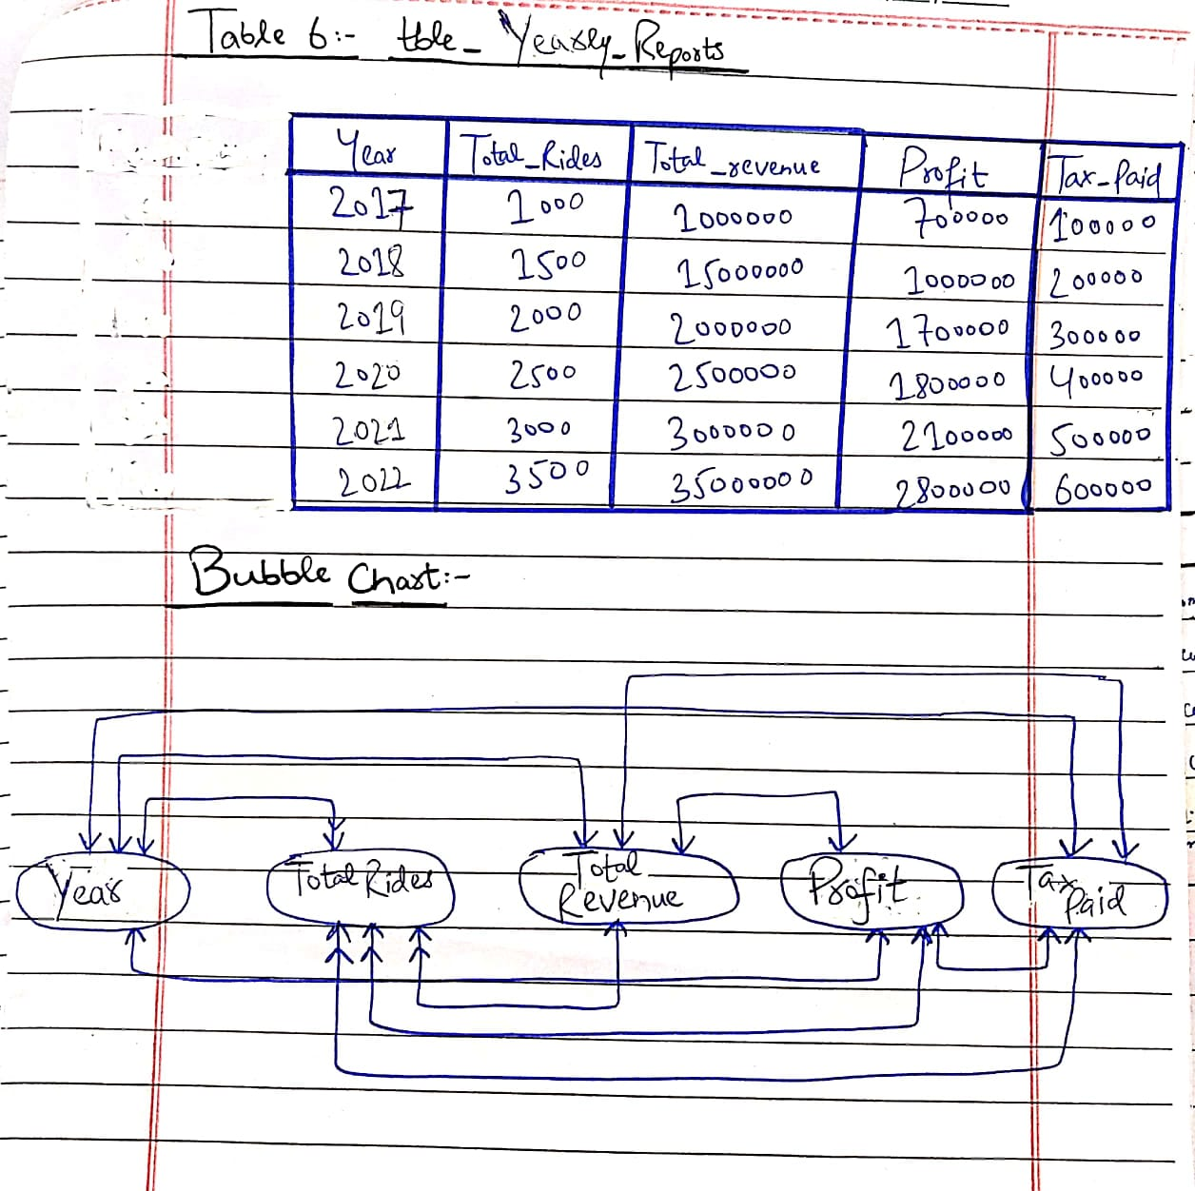

**Candidate Key Attribute:** Year, Total Revenue, Profit, Tax Paid

**Primary Key Attribute:** Year

**Alternate Key Attribute:** Total Revenue, Profit, Tax Paid

**Secondary Key Attribute:** Total Rides

**4.5 Data Structure Diagram (DSD):**

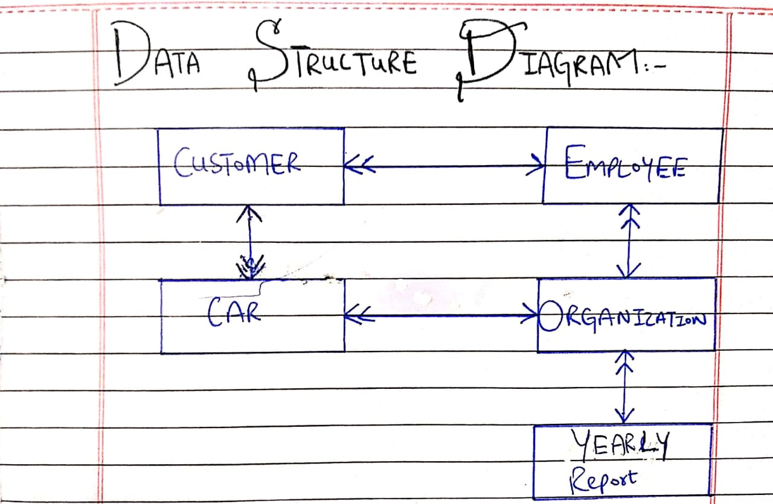

**4.6 Entity Relationship Diagram (ERD)**

**Entity Relationship Diagram (ERD) Old Convention:**

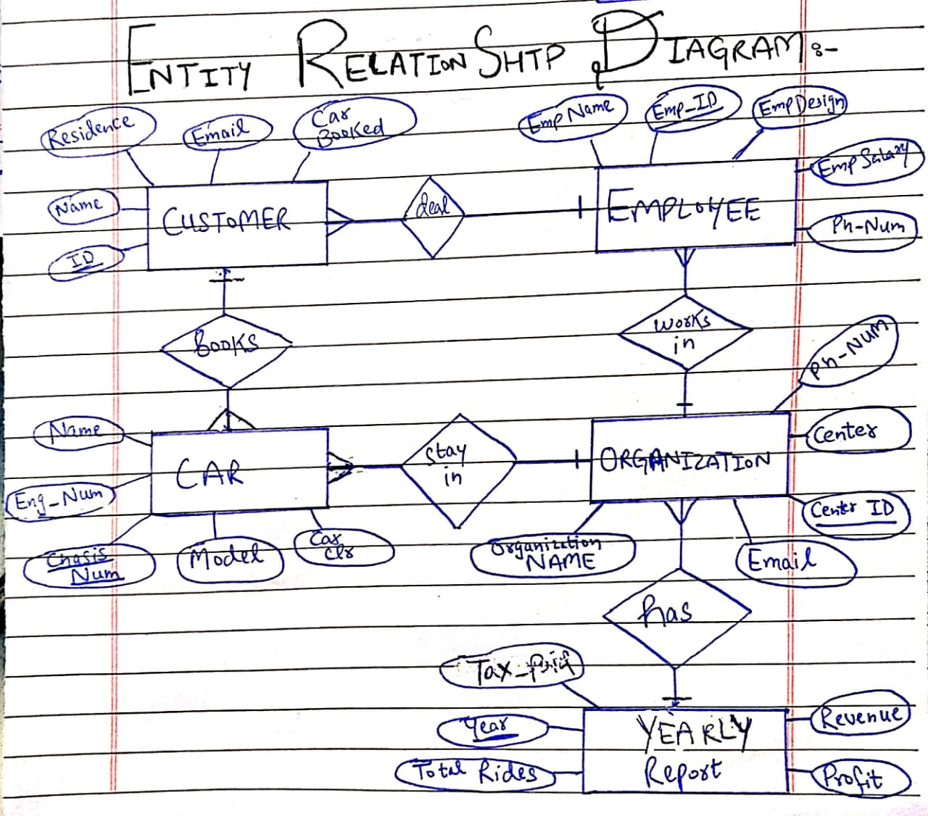

**Entity Relationship Diagram (ERD) new Convention:**

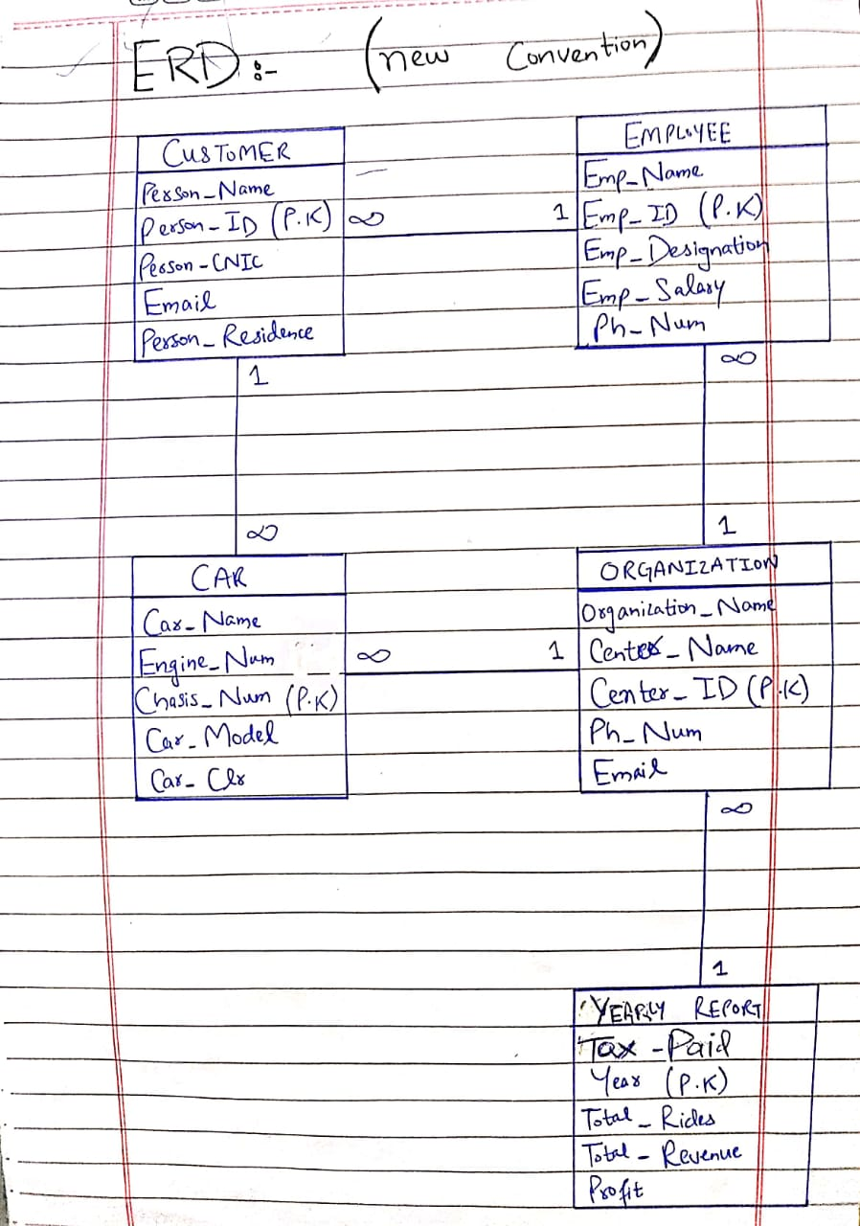

**5.0 Logical Data Model:**

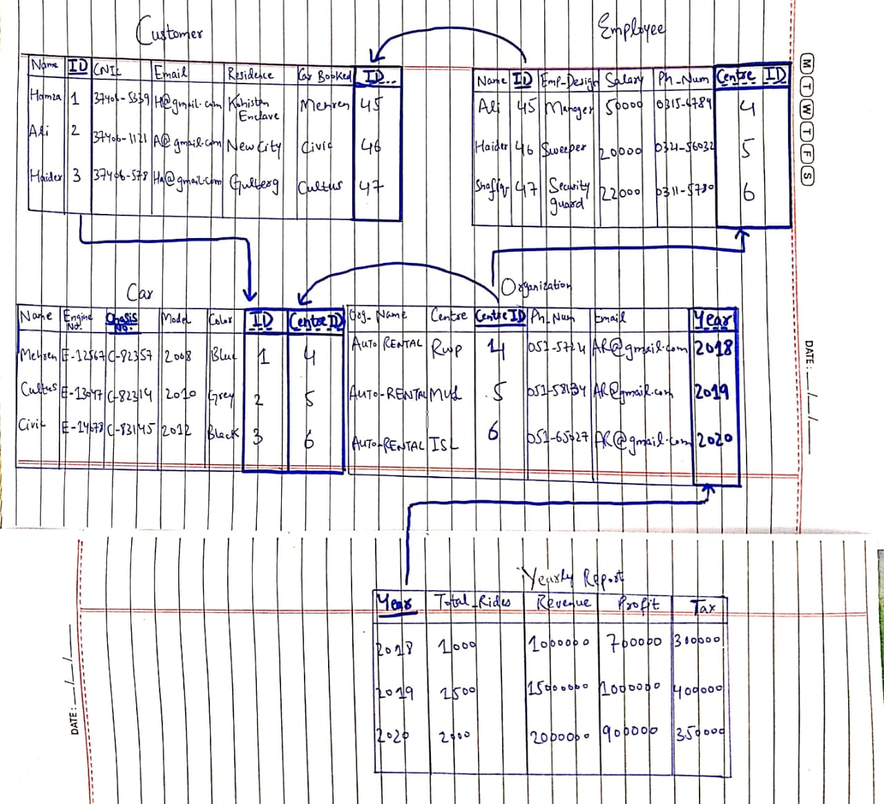

**5.1 Representation of Entity Classes**

The five entity classes and their attributes are as follows:

* Organization (Organization Name, Center, Center_ID, Ph_Num, Email)
* Car (Car_Name, Engine_Num, Chasis_Num, Car_Model, Car_Clr)
* Customer (Name, ID, Email, Residence, Car_Booked)
* Employee (Emp_Name, Emp_ID, Emp_Designaion, Emp_Salary, Ph-Num)
* Yearly Report (Year, Total_Rides, Total_Revenue, Profit, Tax_paid)

**5.2 Representation of Relationship between Entity Classes**

In order to represent relationship, we consider degree of relationship and type of relationship.

As in ERD and DSD, the relationship between entity classes was one to many (1: M), so when we have a relationship of one to many, we take Primary key of one side relation as a foreign key in many side relation.

1. **Binary + 1: M (Employee-Customer)**

We take Primary key of one side relation (Employee) as a foreign key in many side relation (Customer). Primary key **“Emp_ID”** of Employee has now become the foreign key in Customer entity class.

**2.** **Binary + 1: M (Customer-Car)**

We take Primary key of one side relation (Customer) as a foreign key in many side relation (Car). Primary key **“ID”** of Customer has now become the foreign key in Car entity class.

1. **Binary + 1: M (Organization-Employee)**

We take Primary key of one side relation (Organization) as a foreign key in many side relation (Employee). Primary key **“Centre_ID”** of Organization has now become the foreign key in Employee entity class.

1. **Binary + 1: M (Organization-Car)**

We take Primary key of one side relation (Organization) as a foreign key in many side relation (Car). Primary key **“Center ID”** of Organization has now become the foreign key in Car entity class.

1. **Binary + 1: M (Organization-Yearly Report)**

We take Primary key of one side relation (Yearly Report) as a foreign key in many side relation (Organization). Primary key **“Year”** of Yearly Report has now become the foreign key in Organization entity class.

**6.0 Forms**

**form: Organization**

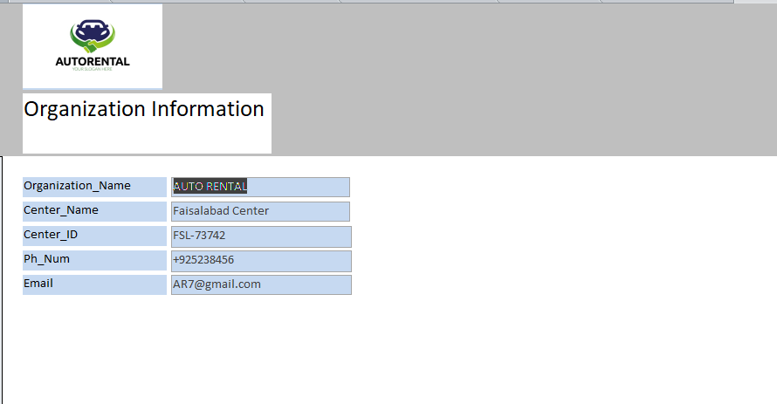**form: Car**

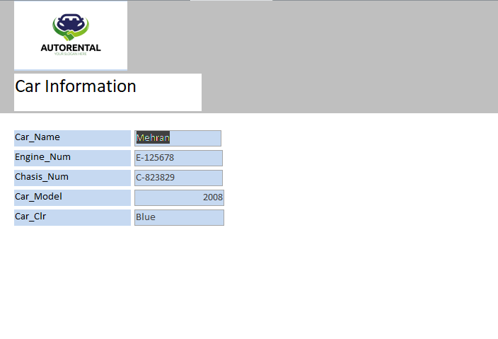

**form: Customer**

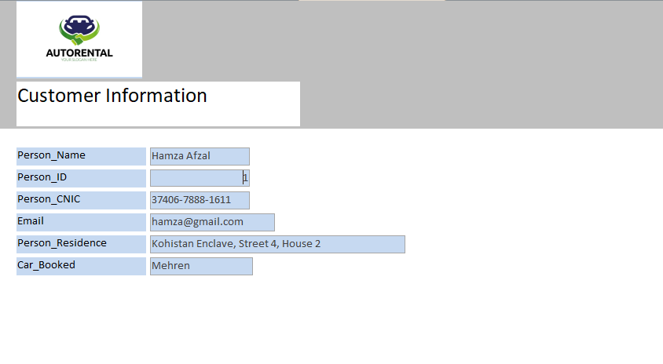

**form: Employee**

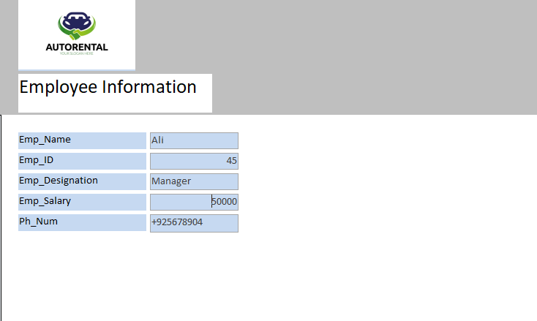

**form: Yearly Report**

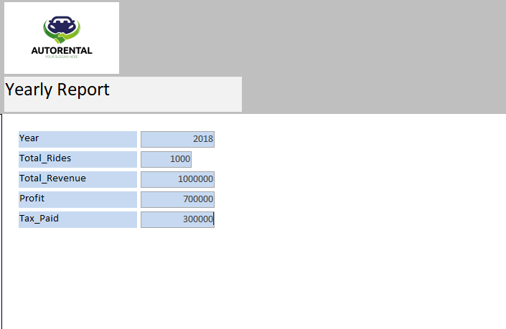

**7.0 Reports**

**report: Organization**

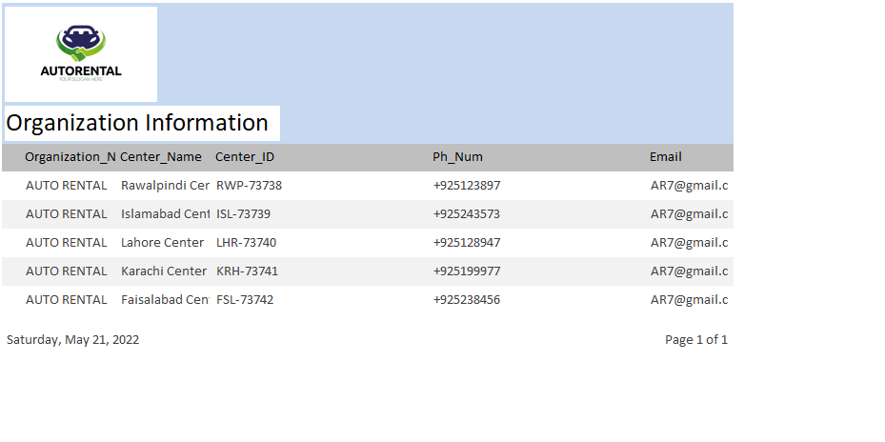

**report: Car**

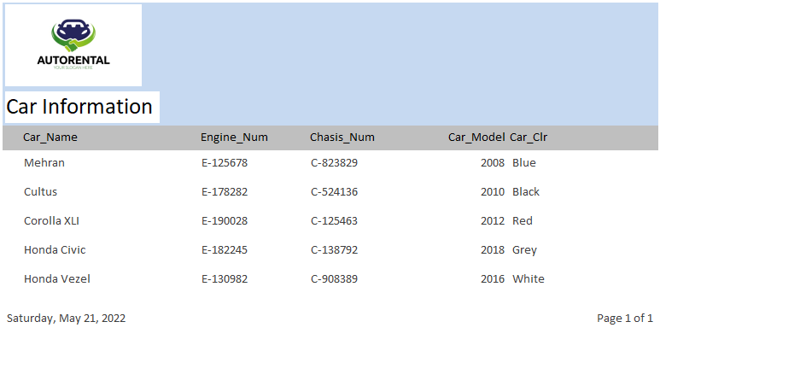

**report: Customer**

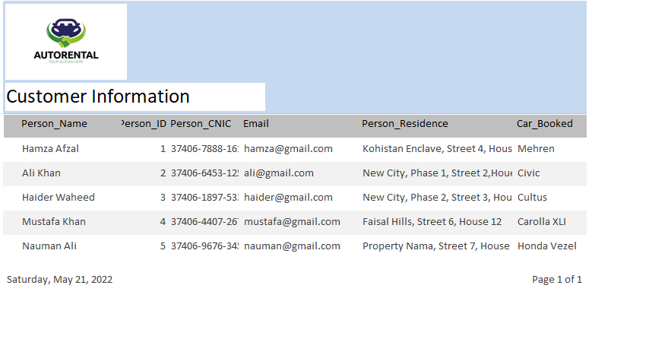

**report: Employee**

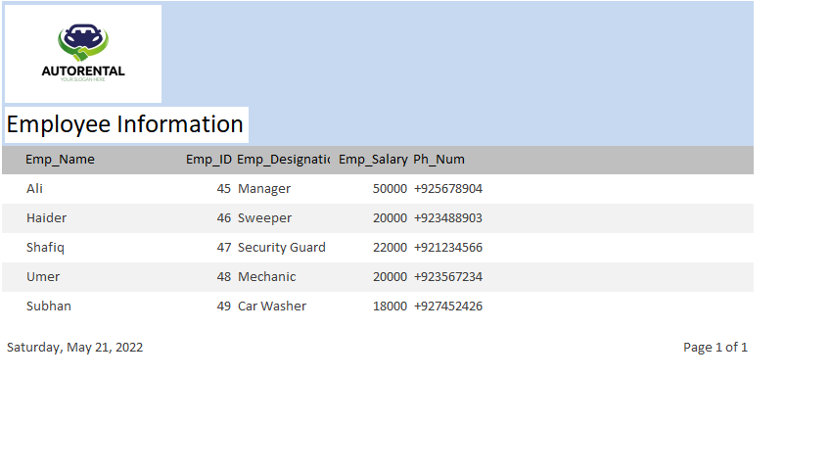

**report: Yearly Report**

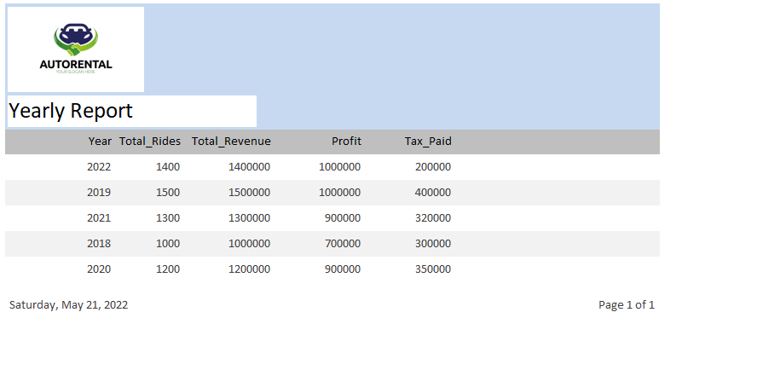

**The**

**End**